DC LAMP INTENSITY CONTROL USING PWM SIGNAL
An N-Channel Enhancement MOSFET (Metal-Oxide-Semiconductor Field-Effect Transistor) acts as an electrically controlled switch or amplifier. It is normally OFF (no current flows). Applying a positive voltage to the gate terminal creates an electric field, "enhancing" a conductive path of electrons to let current flow between the source and drain
Key Terminals
- Source (S): The terminal where electrons enter the transistor.
- Drain (D): The terminal where electrons leave.
- Gate (G): The control terminal, insulated from the rest of the device by a thin layer of Silicon Dioxide (SiO₂).
- Substrate (Body): The base semiconductor material (usually P-type).
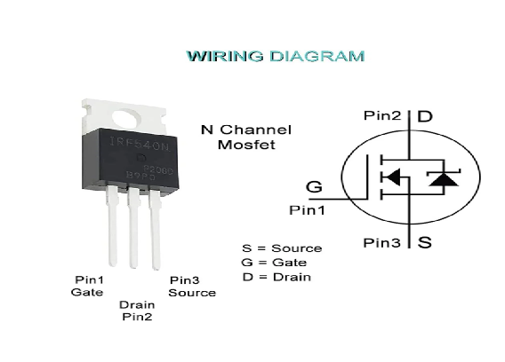

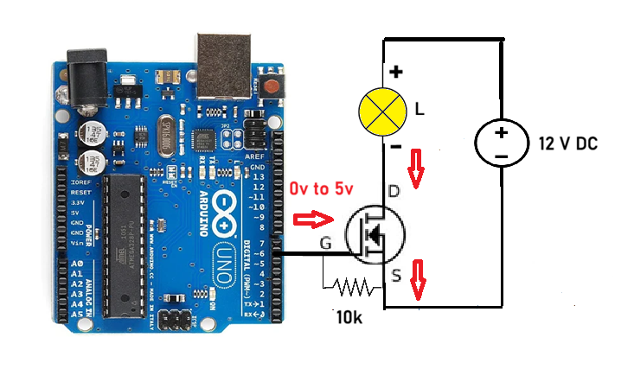
Program
int ledPin = 9; // LED connected to digital pin 9

void setup() {
// nothing happens in setup
}

void loop() {
// fade in from min to max in increments of 5 points:
for (int fadeValue = 0; fadeValue <= 255; fadeValue += 5) {
// sets the value (range from 0 to 255):
analogWrite(ledPin, fadeValue);
// wait for 30 milliseconds to see the dimming effect
delay(30);
}

// fade out from max to min in increments of 5 points:
for (int fadeValue = 255; fadeValue >= 0; fadeValue -= 5) {
// sets the value (range from 0 to 255):
analogWrite(ledPin, fadeValue);
// wait for 30 milliseconds to see the dimming effect
delay(30);
}
}

